**Pointers, Dynamic Arrays and Exception Handler**

**(use do-while loop first for validating values)**

**DIRECTIONS:**

Please complete the code and make it work by adding an appropriate code in the “add code” or “call to function” parts.

**Note:**

Copy and Paste the program below in your source file and you are required to add codes if necessary. You cannot OMIT given codes and/or function /No modification should be done in the given codes (main function and function prototypes).

**Please be guided accordingly. (Just make the code work, thank you!)**

#include<iostream>

#include<iomanip>

using namespace std;

const int size=10;// use in menu[1] miles per gallon

typedef double *pointers;

void MilesPerrGallon(double *ptr1,double *ptr2);//process and display milespergallon

void MperG();//input miles and gallons and call function MilePerGallon

void getSort();//use dynamic array and a sort techniques to sort n values

void displaySort(int *ptr,int smax);//displaying the vsorted values in descending order

char displayMenu(char *pt);//display the option on screen and return values 1,2 or 3

//using a pointer variable

int main()

{

char ans,sagot;

char *ptr;

//add code here

switch(sagot)

{

//add code here

}

/////////////////////////

void MperG()

{double miles[size],gallons[size];

int ctr;

pointers milPtr,galPtr;

system("cls");

cout<<"COMPUTING FOR MPG : miles per gallon...\n";

cout<<"MILES\n";

//add code here

/*********************************************************/

cout<<"GALLONS\n";

//add code here

//call MilePerrGallon here

}

////////////////////////

void MilesPerrGallon(double *ptr1,double *ptr2)

{

double mpg[size];

pointers mpgPtr;

int index;

//add code here

}

///////////////////////////////////////

void getSort()

{

//add code here

//call displaysort here

}

/////////////////////////

void displaySort(int *ptr,int smax)

{

//add code here

}

////////////////////////////////////////////

//////////////////////////////////////////

char displayMenu(char *pt)

{

//add code here

return *pt;

**Sample Output:**

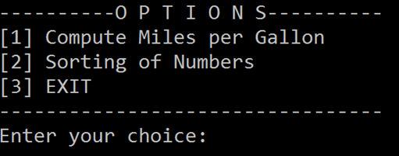

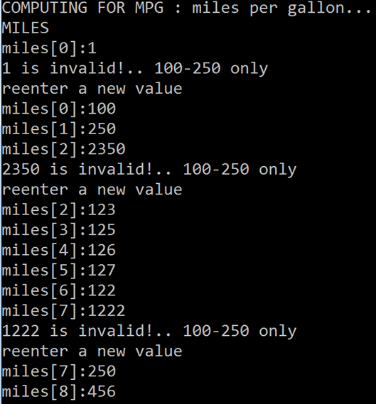

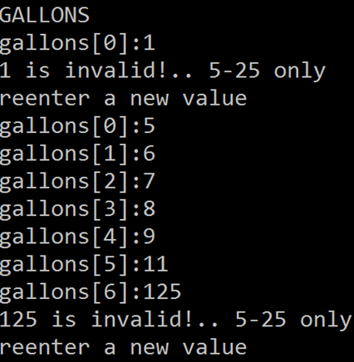

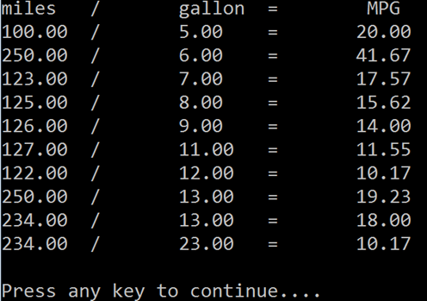



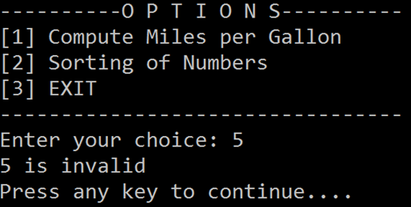



***Accept only 5 to 20 input numbers for sorting

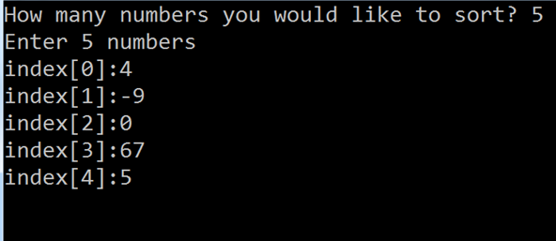

Output:

Numbers in descending order:

67 5 4 0 -9

Numbers in ascending order:

-9 0 4 5 67